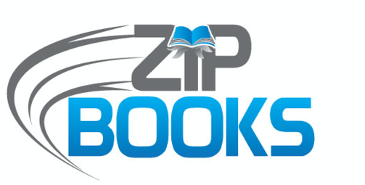

What do you think of Zip Books?

How easy was it to understand the request process?
Very Easy Easy Moderate Difficult

How many days did it take the book to arrive at your home?
1-3 4-6 7-9 10 or over

How likely are you to use Zip Books again?
Very Likely Somewhat Not Likely

How would you rate the overall experience?
Excellent Good Fair Poor

How far is your home from your library (in miles)?
1-5 6-10 Over 10 Over 20

ENTER YOUR LIBRARY’S LOGO HERE

Your comments:
____________________________________________________________________________________________________________________________________________________________________________________

ENTER YOUR LIBRARY’S NAME AND ADDRESS HERE

Zip Books is a statewide project of the NorthNet Library System and Califa Group, funded by the California State Library.

