STATE OF CALIFORNIA EDMUND G. BROWN, Jr., Governor
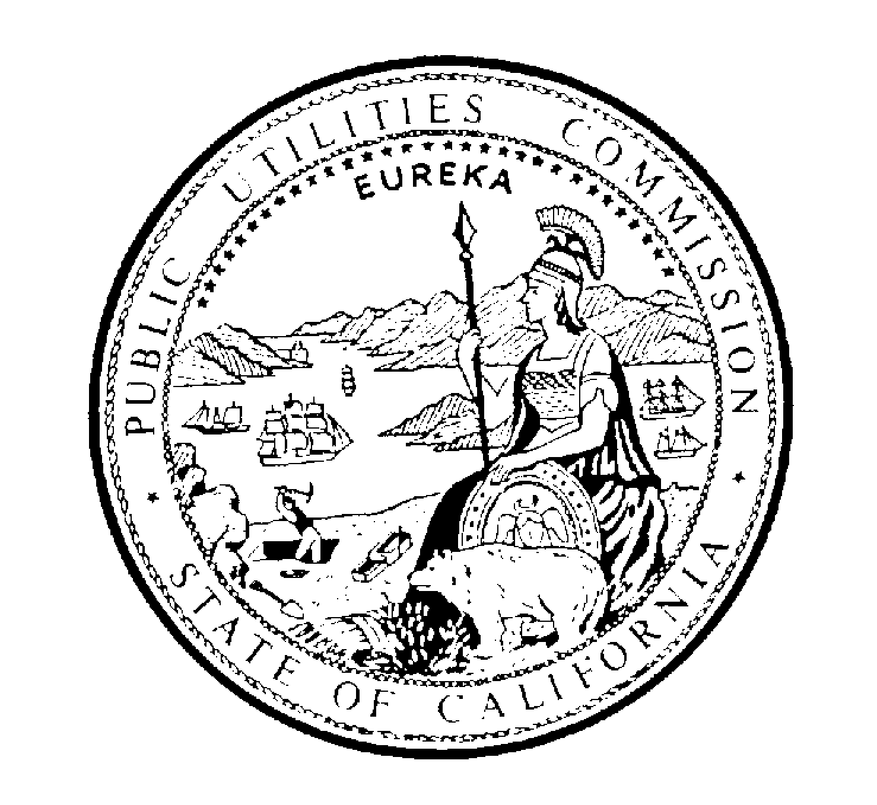
PUBLIC UTILITIES COMMISSION
505 VAN NESS AVENUE
SAN FRANCISCO, CA 94102-3298

Letter of Authorization

We, the undersigned, authorize the Califa Group (Califa) and the Corporation for Education Network Initiatives in California (CENIC), to act on our behalf to complete, sign, and submit an application and supporting documentation for the California Teleconnect Fund (CTF) to the California Public Utilities Commission for the purpose of receiving CTF discounts on eligible communications services.

We certify that the information provided herein is true and correct to the best of our knowledge and belief. Any acts carried out by Califa and/or CENIC on our behalf pursuant to this authorization shall have the same effect as acts of our own. This authorization shall remain in effect until revoked by the undersigned in writing.

________________________________________________________________________
PRINTED NAME OF LIBRARY/ LIBRARY SYSTEM OR JURISDICTION

___________________________________________ ________________________
SIGNATURE OF AUTHORIZED PERSON DATE

___________________________________________
PRINTED NAME OF AUTHORIZED PERSON

___________________________________________
TITLE OR POSITION OF AUTHORIZED PERSON

______________________________________________________________________________
ADDRESS OF LIBRARY/LIBRARY SYSTEM OR JURISDICTION

___________________________________________
PHONE NUMBER OF AUTHORIZED PERSON

___________________________________________
E-MAIL OF AUTHORIZED PERSON

